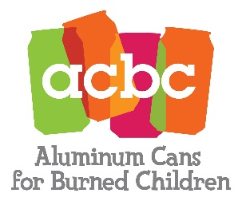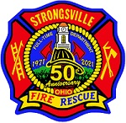

*acbc*

**Aluminum Can Collection**

**In 1986 the Northern Ohio Fire Fighters, the Northeast Fire Chief’s Association, along with MetroHealth Medical Center of Cleveland started the Aluminum Cans for Burned Children Foundation (ACBC) to help children who suffer severe burn injuries. The ACBC program pays for special medical equipment not normally covered by insurance to aid in the healing process. ACBC strives to meet the individual needs of the patients and provides rehabilitation, clothing, toys, games, computer and video equipment, and other miscellaneous items not covered by insurance.  
  
Since 1988, burn survivors from age 5 to 16 have been able to enjoy a free, four-day retreat at Camp Phoenix. Camp Phoenix is held in the summer and winter at Camp Cheerful, in Strongsville, Ohio. The camp experience brings together some fifty burned children to enjoy a fun, therapeutic camping experience with others who have suffered similar injuries. The aim is to create a secure environment providing an atmosphere to promote interaction and help the children to better cope with their injuries. They also hear from other burn survivors who have successfully recovered.  
  
The ACBC program offers a scholarship program open to any pediatric patient who has been an inpatient at the Burn Center. The program annually awards scholarships to qualified recipients at an accredited school or university.  
  
The ACBC program provides a Fire Safety Houses to elementary schools and community home days promoting fire safety in the home. Operated by firefighters, the houses are actually 28-foot trailers built to resemble two-story homes. The goal of ACBC is to educate young children about the dangers of fire, how to call 911 in the event of an emergency, what to do if there is a fire in their home, and other important fire safety tips. Over 3,000 Northeast Ohio school children tour the Fire Safety Houses annually.**

**More than 85 fire stations throughout Northeast Ohio participate in ACBC’s can recycling program–a major source of income for our fire prevention education and childhood burn survivor programs. Drop-off your bagged aluminum beverage cans at any location listed below that is convenient to you. Bins marked with the ACBC logo are usually located behind the stations. Please stop at any of Strongsville’s fire stations and donate your aluminum cans.**

|  |  |  |  |  |
| --- | --- | --- | --- | --- |
| Strongsville Fire Sta. #1 | 11297 Webster Rd. | Strongsville | Ohio | 44136 |
| Strongsville Fire Sta. #2 | 15939 Drake Rd. | Strongsville | Ohio | 44136 |
| Strongsville Fire Sta. #3 | 32200 Albion Rd. | Strongsville | Ohio | 44136 |
| Strongsville Fire Hqts. | 17000 Prospect Rd. | Strongsville | Ohio | 44136 |

For more information, click the link <http://www.acbcohio.org/>